*Technical Design Document*

*Able WARS*

**Part 1:**

* Target Platform: Standalone PC, Mobile
* Development Platform: CSS, HTML5, JS, (Node JS OR Signal R)
* Source Code Host: GITHUB
* Third Parties SDK’S or API’S: Socket IO, Apache Cordova, Signal R
* External Tutorial Resources: There will be no existing software as a starting point
* External Assets: We plan on both creating our own visual assets, as well as using royalty free images and backgrounds as well if needed.
* External Database & Virtual Host: Yes, we need a VM server to host our application and environment. We will be using a MySQL database, and a windows server.

These are the technologies set to be used. There’s only one decision left to be made regarding our technology stack, and that is what will be used as our client-to-client communication technology. We are deciding between NodeJS (Socket-IO) and Signal-R (.NET). Furthermore, I will be discussing with William Barry our C# professor, the possibility of completing our final C# project by doing a Signal-R implementation in our capstone.

**Part 2:**

Our Project Milestones are below, there are a total of 10. We understand you mentioned a total of 6 in the guidelines, but our group felt the need to be a bit more specific and really analyze each milestone for what it is. I hope that is fine by your standards. The bolded headers indicate milestones that will be completed up to the alpha build.

* **Technology Stack Researched and Confirmed - Tuesday 27 September**
  + Entire Team: Research Server to Client communication (Socket IO or Signal R)
* **Setting Up Environment (Basic UI & Database) - Friday 30 September**
  + Enzo: Following up on Avery’s network research and help Levon Implement necessary front-end environment
  + Auquib: Implement MySQL server on VM
  + Levon: Implement basic HTML, CSS, JQUERY pages on VM
  + Bilal: Help Auquib implement database model into VM
* **Complete Backend Setup for Alpha Build - Tuesday 11 October**
  + Enzo: Assist Bilal in setting up controllers
  + Auquib: Finish up database modeling
  + Avery, Levon: Set up environment for real time communication
  + Bilal: Set up controllers for alpha build
* **Complete Alpha Build – Friday 14 October**
  + Enzo: Collaborate with the team in order to ensure all required components of the alpha build are implemented
  + Auquib: Verify database model
  + Levon: Verify front-end components and controller integration
  + Avery: Ensure a client versus client connection can take place
  + Bilal: Finalize back-end, front-end controller’s integration
* Revisit Backend and Real Time Integration - Thursday 3 November
  + Entire Team: Discuss how all parts integrate with each other, conduct test cases in order to find potential glitches or bugs
* Develop & Test Core Gameplay Mechanics – Thursday 10 November
  + Enzo: Develop core mechanic functions, making sure gameplay stays loyal to original design
  + Auquib: Confirm the database is receiving all data as expected
  + Levon: Develop core mechanic functions alongside Enzo
  + Avery: Ensure all party members can be connected to start match at same time, and stay in-lobby
  + Bilal: Make sure controllers handle data correctly, sending data to server
* Construct Styling Sheets and Game Visuals - Friday 25 November
  + Entire Team: Develop CSS file, gathering necessary visual assets such as images, lastly edit visual assets with Photoshop and Illustrator
* Build & Test for Beta – Tuesday 29 November
  + Enzo: Collaborate with the team in order to ensure all required components of the alpha build are implemented
  + Auquib: Verify database functionality
  + Levon: Verify front-end components and controller integration
  + Avery: Ensure a client versus client connection can take place, hosting multiple players
  + Bilal: Finalize back-end and front-end controller’s integration
* Fix Found Issues & Retest– Wednesday 14 December
  + Entire Team: Verify source of bugs or other issues and tackle it as a team
* Build Final Package – Wednesday 21 December
  + Entire Team: All members will get together to create a final build and commission it

**Part 3:**

Below are the requested diagrams, legends added on the right.

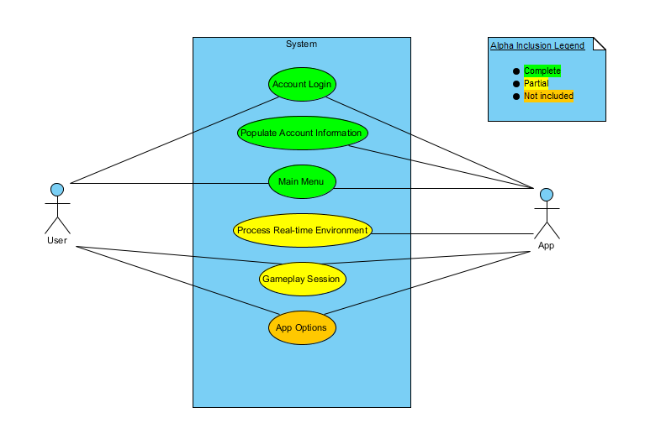

Use Case Diagram

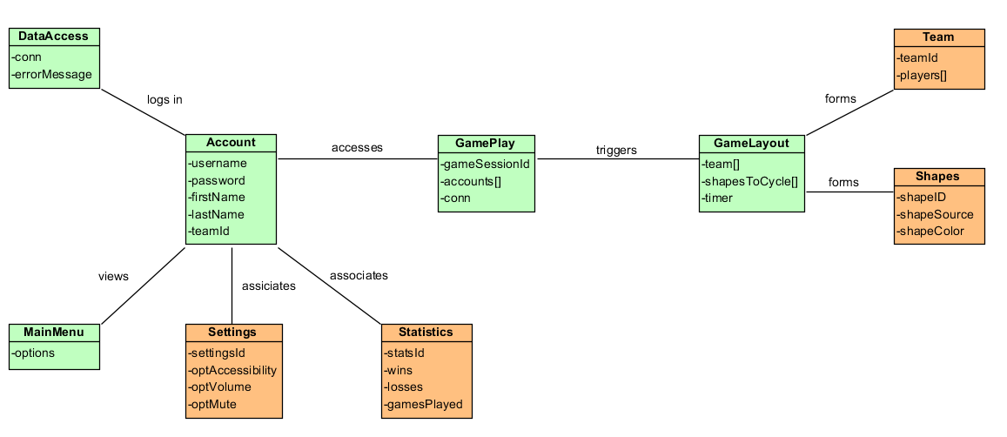

Class Diagram

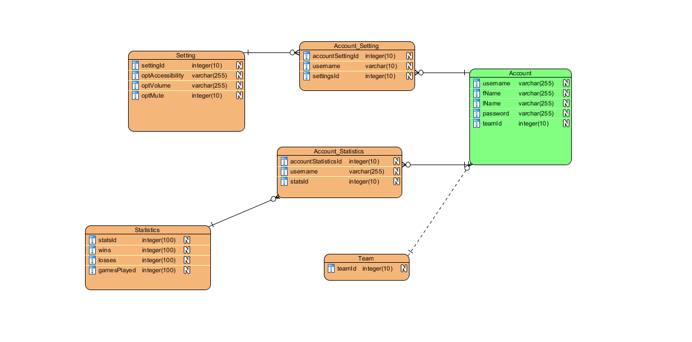

Entity-Relation Diagram

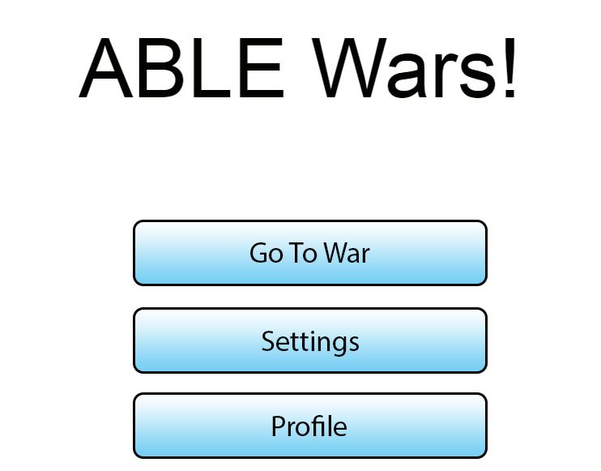

Alpha Main Menu Mockup

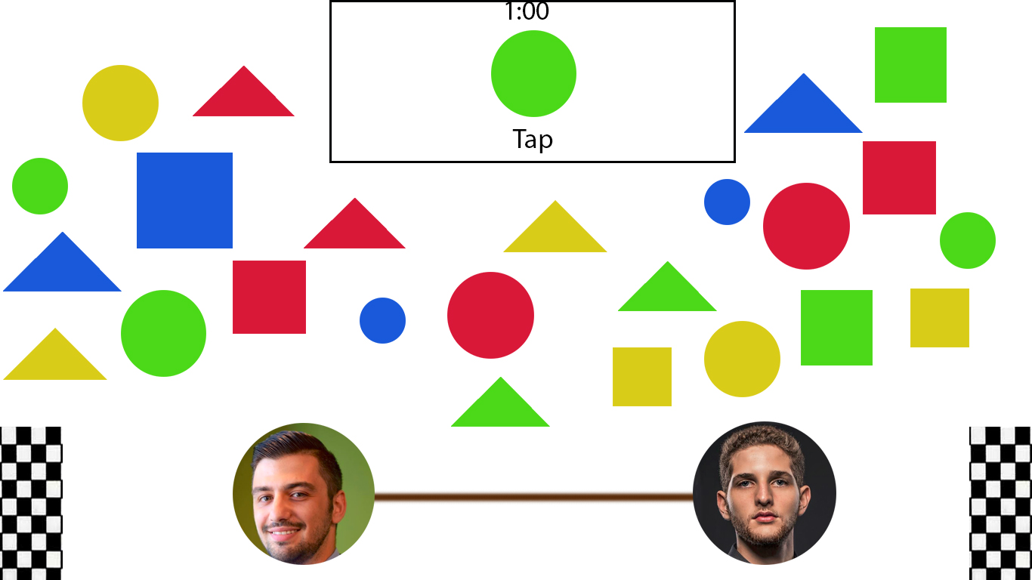

Alpha In-Game Screen

Disclaimer: Please keep in mind these images and plans are subject to changes throughout development. We plan on implementing more features as the project goes on. For the alpha build, our main goal is to establish a hosted player versus player match.